Dream color led corner floor lamp

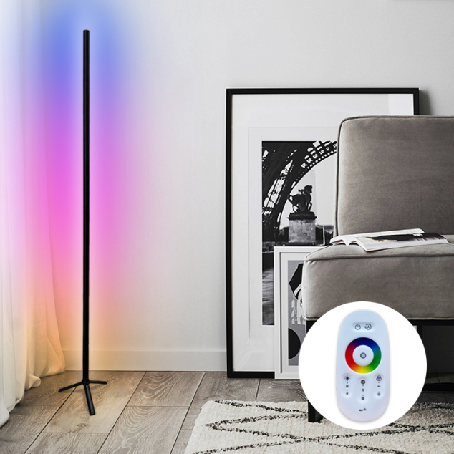

How to use ?
1.Slid the switch on the cap to “ ON”, and then use remote controller to control the
under cabinet light. Please slide the switch on the cap to “ OFF” to hold battery power
if you don’t use the under cabinet light for long time.
- Controller

Turn light on and off.

pause

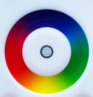
16 million different color for you to choose

adjust the brightness

adjust the speed

multiple modes for you to choose

How to install the under cabinet light ?
